1. Setup Zach Benn
2. Sentence structure March 30, 1999
3. Phrases L.A. Morning

Mitter Frump

Walking nonchalantly down the old stone walkway Mitter spied an elderly mouse waving his staff madly in the air. Mitter cautiously approached the old mouse being careful not to get too close. The old mouse stopped waving his staff and looked at Mitter before saying "Mr. Frump, I've been waiting."
"Waiting for what", Mitter inquired.
"Why for you of course," the old mouse yelled. He then broke out into a chant
"Over a ditch
Through a hill
To a room where light burns still."
Then like a bolt of lightning the old mouse leapt into a patch of bushes leaving behind a small pouch containing; a silver dagger and an old parchment bearing the words the mouse had just spoken. Mitter retrieved the pouch and continued along his way while trying to make sense of what had just passed.

That night he made camp in a cluster of small trees. He had just settled down when without warning a long stalk of bamboo hit him on the head. He looked up and caught a glimpse of the old mouse before he leapt from his high tree perch. After this Mitter could not sleep so he picked up his possessions and headed once more toward his home.

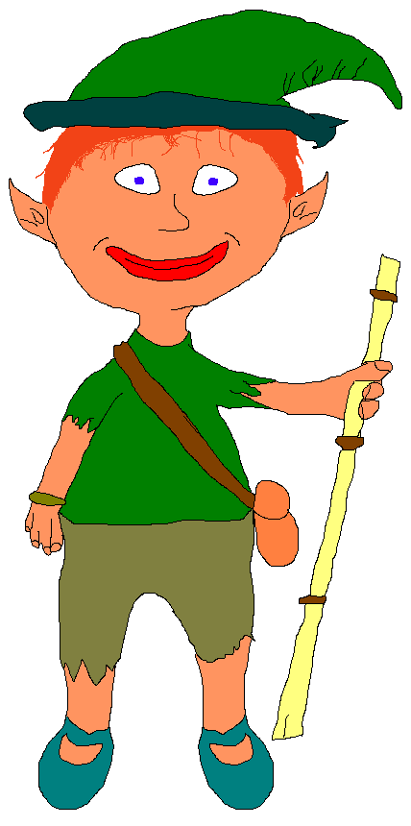
By morning Mitter could just see his village in the gray morning light. Mitter was a short plump little fellow who wore a green cap and an old tunic. He was well liked by all the villagers and was very helpful. His hair was bright orange and his eyes were as blue as the sky. The stone walkway Mitter was on went through the middle of town. On each side of the walkway were homes covered with soft green moss, gigantic trees shaded the village from the harsh sun. Mitter let forth a great sigh. Rejuvenated by the sight of home he made good time and arrived home by noon.
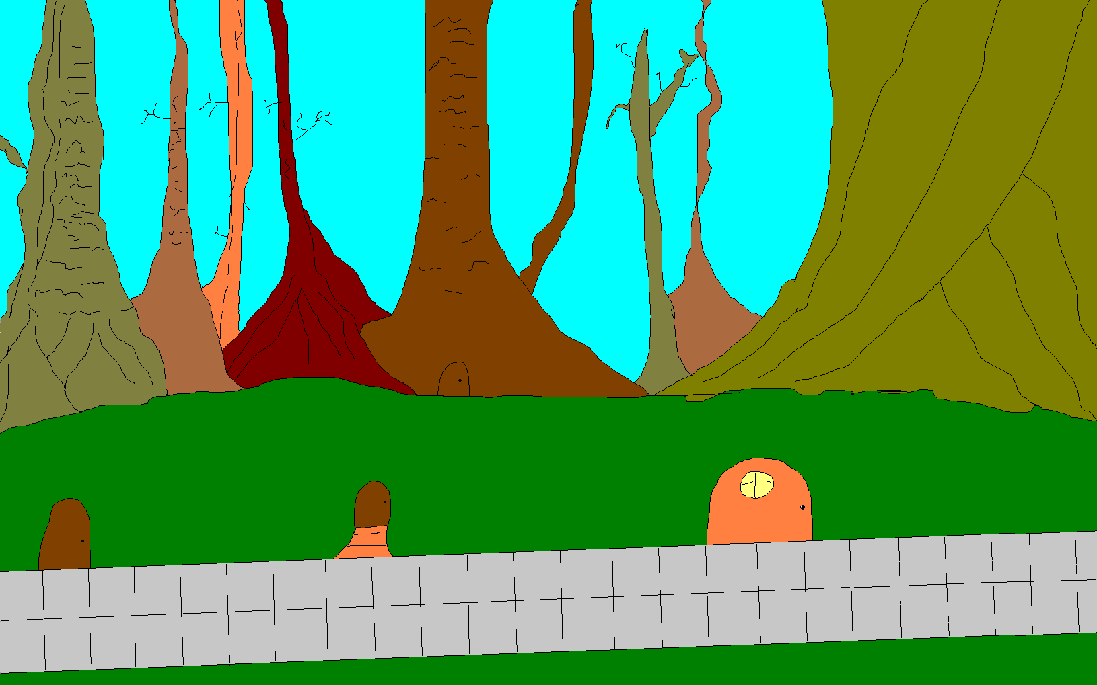
He had just settled down to a snack when he was interrupted by some peculiar noises coming from outside. He opened the door and there lay a wretched gnome, moaning and whimpering pitifully. Mitter brought the gnome in and lavished him with hot soup. After gulping down many bowls he introduced himself as Bodo. "I thank you for saving me and as a reward I would like to present you with this Gnomian shield." Bodo pulled a brightly polished shield out of this sack and presented it to Mitter. Mitter thanked the gnome and invited him to stay the night. But, Bodo refused and left him with his new gift.

Mitter took out the dagger which the old mouse had left behind and equipped himself with his new shield. He danced and whirled around the room stabbing and slashing at imaginary enemies. This soon became boring and Mitter fell into a deep sleep. He awoke in the middle of the night and noticed smoke coming from his pantry. He grabbed his shield and pouch then he dashed outside. To his horror the entire village was aflame. He ran for cover in a grove of trees and watched his entire life work go up in flames.

He woke up early in the morning; he rubbed his eyes, stretched, and then noticed his surroundings. The occurrences of the night before raced back to him. He went to inspect the ruins and spent many hours rummaging through what had once been his home. As he was leaving Mitter slammed his fist into the singed doorway. No sooner had he done this when all that was left of the burned house fell to the earth. Mitter quickly jumped out of the way he turned to look at the ruins and spied a piece of parchment protruding from the wreckage of what had been his home. Mitter stumbled to the parchment then removed it from the rubble. He studied it thoroughly. He knew it was a map but not where it led to. Deep down inside Mitter thought it might lead him to an answer for the recent occurrences.
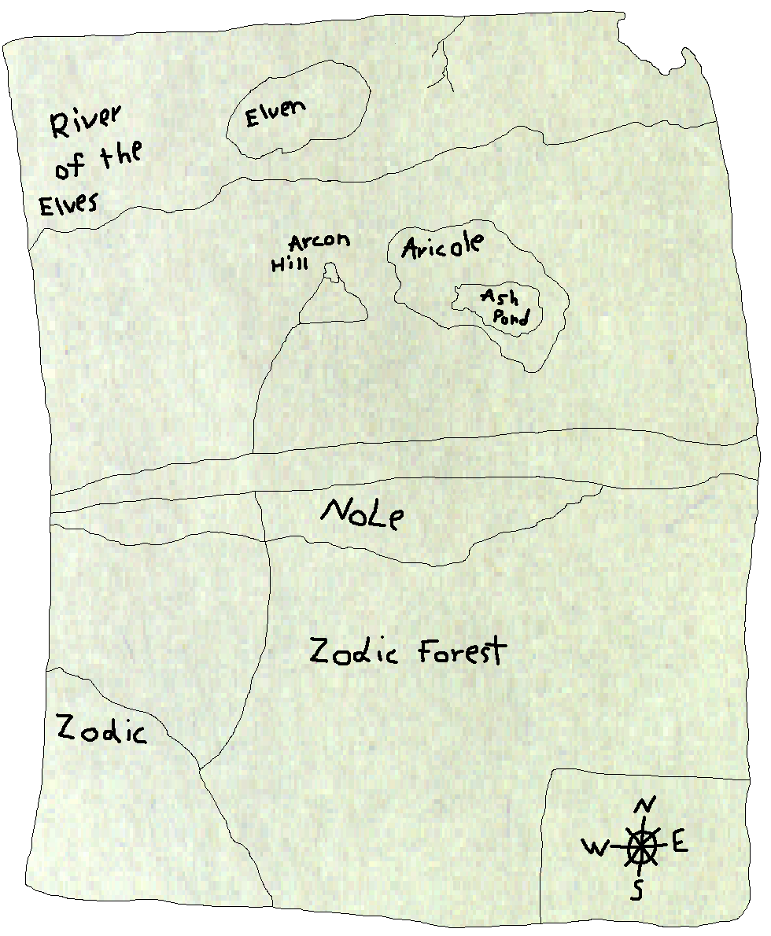
Mitter spent the night in the same patch of trees he had the night before. His sleep was restless and he woke up far before the first gray light shone through the dark clouds. He studied the map once more before he stuffed it into his pouch. Then he headed in the direction the map had instructed. The going was rough at times but the majority of the way was enjoyable. On the third day of his journey Mitter came to a city of gnomes. At the far end of the city was a monstrous ditch. Mitter walked about a mile each way in search of a route across. He tapped the shoulder of a gnome walking by. Mitter asked the gnome if there was a way across the ditch. The gnome gave him directions to someone he said could help him. Mitter found the spot with little difficulty. He also found that the only way across was a piece of twine attached to a tree on either side of the ditch. A basket would be pulled along with pulleys. Mitter entered the basket and was pulled to the opposite side. Mitter exited the basket and walked about a mile before he set up camp.

He woke with the sun and continued. Mitter walked through thick patches of trees till he came to a round clearing. In the center he saw a symbol. The symbol was a sunburst held up by tiger paws. When Mitter stepped on the symbol he heard a roar surrounding him. Then out of the shadows came a grotesque snarling face soaked with saliva. As he approached Mitter his long claws dug into the earth. He snapped his tail back and forth. His right eye had been injured and was swollen shut. Mitter took out his shield and dagger and wielded it menacing at the cat like beast.
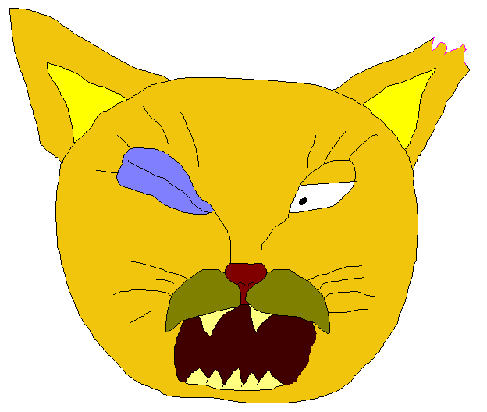
The enemy approached slowly but one swipe of his mighty paw sent Mitter flying through the air. He approached the strange creature, keeping his shield in front of him. The face of his cat like enemy grew tense; he drew back and prepared to pounce. As soon as he was in the air Mitter ran underneath of him and slashed at the giant cat's underbelly, disemboweling him. As soon as the bloody mass of fur and intestines hit the ground they started to dematerialize. Then the figure of the old mouse appeared, giggling wildly. He recited his chant again this time leaving out the first line.
"Through a hill
To a room where light burns still."

Then in the center of the clearing a quiver full of arrows and a bow materialized. Mitter retrieved the gifts, studied his map then continued. He limped slightly but still made good time. Soon he came to a large hill. He rested against a tree and studied the piece of paper that the old mouse had left behind. After a few minutes Mitter started searching for a way through the hill. He found a small hole then took out his bamboo stalk and shoved it into the hole. He pushed the stalk until a crack formed in the hill. As he pushed the stalk the crack grew larger until a tunnel, big enough for Mitter to crawl through formed. At the end of the tunnel lay a room with six small unlit torches surrounding one lit torch. Mitter took out his bamboo stalk lit the end on fire and ran around franticly lighting the six small torches. As soon as this was accomplished a tremor shot through the room and the floor began to rise.

When it finally came to rest Mitter found himself in a gigantic room. The smell of rotting corpses was in the air. Suddenly a bright light appeared and Mitter heard a wicked laugh. Then the silhouette of a gnome appeared. He approached Mitter and introduced himself as Acnorme Slate. "I am trying to overpower the entire land. But you my friend are IN MY WAY". Acnorme was just a little taller than Mitter he wore an acorn top on his head, had no right leg and was waving a large spear stained with blood.
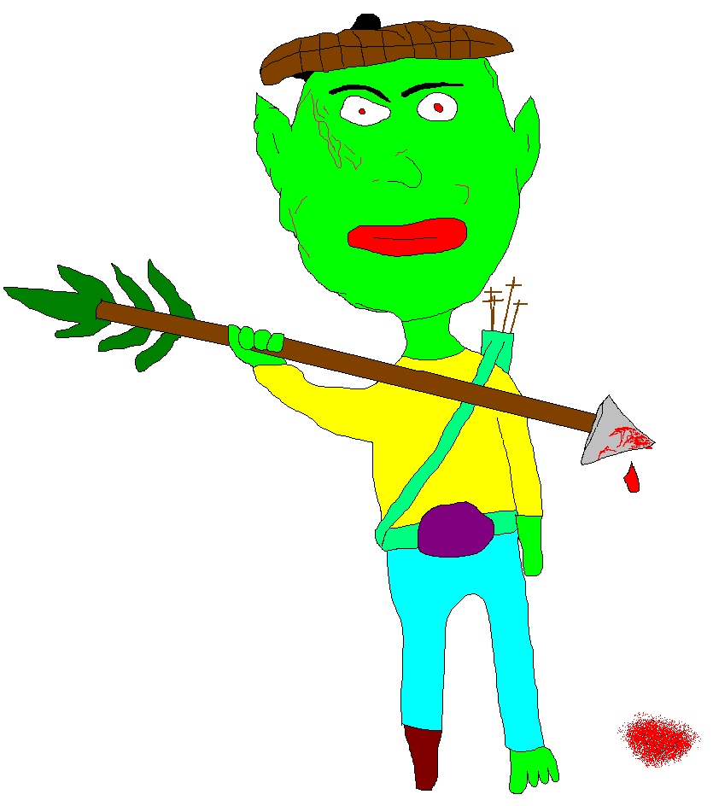
Acnorme leapt at Mitter but Mitter skillfully dodged the attack and dealt Acnorme a hefty blow at the back of his neck. Blood poured from Acnorme's wound. Acnorme lay motionless on the ground. Then the bright light appeared once more and when it was gone Mitter found himself back in the middle of his village. All of the villagers were working busily at repairing the damage. He heard a cackle and looked out at the stone pathway where the old mouse was leaping out of the bushes . . . . .

